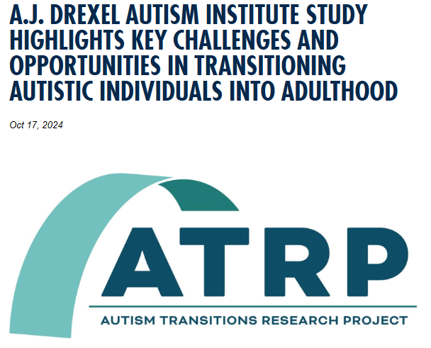
The Autism Transitions Research Project, funded by the Health Resources and Services Administration and led by Drexel University's A.J. Drexel Autism Institute, has released new findings that underscore critical challenges and opportunities in transitioning autistic youth into adulthood. As approximately 1.2 million autistic individuals are expected to reach adulthood in the coming decade, these insights are vital for shaping future research and services.
The study, “Challenges and Opportunities in Transitioning Autistic Individuals into Adulthood,” led by Anne M. Roux, a research scientist and director at the Policy Impact Project in the Autism Institute's Policy and Analytics Center, and a multidisciplinary team, reveals key barriers that hinder successful transitions, including delays in diagnosis and access to services, long waitlists, and an over-reliance on care partners to provide daily supports and to navigate complex service systems. Funded through the Autism Transitions Research Project grant under principal investigator Lindsay Shea DrPH, the study also highlights the importance of cultural considerations and responsiveness as well as the inclusion of autistic individuals in the development of transition services.
Key findings include:
- Significant delays in diagnosis and access to transition services, exacerbate challenges for autistic youth and their families.
- A critical need for peer navigation supports and tailored services for marginalized groups, such as those with intersecting identities.
- Disparities in service availability across geographic locations.
- Difficulty accessing key benefit programs, like Supplemental Security Income, and need for revision of benefits programs that reinforce poverty.
Participants across nine focus groups – which included autistic young adults, care partners, and professionals – emphasized the need for research focusing on the efficacy of transition services, the impact of system performance on outcomes and the need for transformation in service ecosystems.
“This research reflects the perspectives of those most impacted by transition challenges and offers a pathway to more inclusive and effective solutions,” said Roux. “It is essential that we prioritize autistic perspectives and account for cultural differences when designing transition services and supports.”
The study’s recommendations include developing population-level research to assess system performance, improving service delivery for marginalized groups and transforming the complexity of service ecosystems to better support successful transitions for all autistic youth across differing life experiences.
For more information about this study, please contact Anne M. Roux.

Contact
Annie Korp
215.571.4244 amk522@drexel.edu

