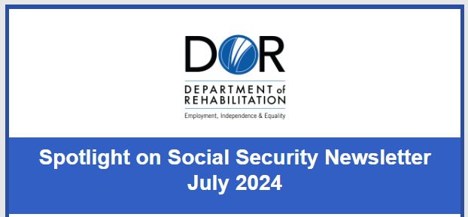

Featured Spotlight Article – Understanding Social Security Overpayments and What You Need to Know

An overpayment occurs when the Social Security Administration (SSA) determined that you received more money than you were entitled. Dealing with a Social Security overpayment can be stressful, but you can handle it by taking some important steps and considering your options for resolving it.

Why Overpayments Occur?

Overpayments can occur for a variety of reasons, below are a few common causes:
- Changes in Income: If your income changes and you don’t report it promptly, you might receive more benefits than you’re eligible for.
- Medical Improvement: Social Security periodically reviews cases to see if your condition has improved. If they find you’re no longer disabled according to their criteria, you may have been overpaid.
- Administrative Errors: Sometimes, mistakes happen. If Social Security makes an error in calculating your benefits, you might receive more money than you should.

Steps to Avoid Overpayments with Social Security

To avoid overpayments, follow these key steps:
- Report Changes Promptly: Immediately inform Social Security of any changes in your income, living situation, or medical condition to ensure accurate monthly payments.
- Keep Records: Maintain records of any income you receive, medical treatments, and communications with Social Security. This can help you verify your eligibility and resolve issues quickly.
- Understand Your Responsibilities: Be aware of what and when to report and stay informed about the rules governing your benefits.

What to Do If You Receive an Overpayment Notice

﻿Overpayments happen, here are a few things to keep in mind if you are told you have an overpayment:
- Review the Notice Carefully: Understand why Social Security believes you were overpaid. Check the dates, amounts, and reasons provided.
- Gather Documentation: Gather any records or documents that support your case, such as pay stubs, medical records, or correspondence with Social Security.
- Contact Social Security: Call the number on your notice to discuss the overpayment within 60 days. Be prepared to explain your situation and provide any necessary documentation.

Options to Consider When Dealing with an Overpayment.

If you do not contact SSA within 60 days, they may begin reducing your monthly benefit payments to recover the overpayment. Some options to consider include:

- Request a Different Repayment Amount: If you agree that you have been overpaid but cannot afford to pay it back at the rate set by Social Security, you can ask for a lower payback amount. You can ask for a monthly payment as low as $10 or 10% of your benefit check, whichever is greater. In this case, file a Request for Change in Overpayment Recovery Rate, Form SSA-634 (SSA-634 Spanish).
- Request a Waiver: If you agree that you have been overpaid, but feel you should not have to pay it back because you did not cause the overpayment and you cannot afford to repay it, file a Request for Waiver of Overpayment Recovery, Form SSA-632 (SSA-632 Spanish) If you want to file a Request for Waiver of the overpayment, it is best to submit the form online.
- Request an Appeal: If you do not agree that you have been overpaid, or you think the amount is wrong, you can file an appeal by completing a Request for Reconsideration, Form SSA-561-U2 (Spanish).
- Request an Administrative Waiver: If you were not at fault for causing the overpayment and repayment would cause financial hardship and your overpayment is $2,000 or less, you can request an Administrative Waiver by phone from your local office or by calling the SSA Call Center at 1-800-772-1213.
- Get Help: If you need assistance understanding overpayments or navigating the appeals process, reach out to Social Security, a disability advocate or legal aid organization. It is critical to address issues promptly if they arise.

These steps outline the general process for each type of request. It's important to follow specific instructions provided by Social Security and to keep copies of all communications and documentation related to your case.

New Rules for 2024 Regarding Overpayment Payback and Withholding

Good news about recent changes to Social Security’s rules about overpayments.
- Extended Repayment Period: Social Security now allows beneficiaries more time to repay overpayments, reducing the monthly payback amount to better accommodate financial situations.
- Withholding Adjustments: Social Security may adjust the amount they withhold to as little as $10 per month to recover overpayments.
- Easier Process: The new rules make it easier to request a waiver of repayment in the event you have no fault and lack the ability to repay.
﻿
Does Social Security Ever Forgive Overpayments?

- Yes, Social Security may forgive overpayments under certain conditions, such as you are not at fault and the repayment would cause you financial hardship. You generally have 60 days from the date of the Notice of Overpayment to file a Request for Reconsideration. A Waiver can be filed any time. Each person’s situation is unique and Social Security handles overpayments on a case-by-case basis.

Where can I Find More Information?

- Contact Social Security at 1-800-772-1213 or your local office. To find an office: Social Security Office Locator.
- 2024 SSA Overpayment Flyer (English and Spanish)
- 2024 Overpayment Fact Sheet
- Your Right to Question the Decision Made on Your Claim brochure (Spanish)
- Ticket-to-Work Overpayments: What you Need to Know
- SSA Blog: Overpayment Recovery Rate

Subscribe to the Spotlight on Social Security Newsletter

Subscribe now to get our Newsletter that focuses on topics related to Social Security Disability Benefits. The Newsletter will keep you updated on the latest news about Social Security benefits and related programs, giving you important information that may help you make informed decisions about your future.

If you missed our past newsletters, you can read them online.

