https://www.apprenticeship.gov/eeo/protected-characteristics/disability

What Do the Apprenticeship EEO Regulations Say about Individuals with Disabilities?

What Do the Apprenticeship EEO Regulations Say about Individuals with Disabilities?
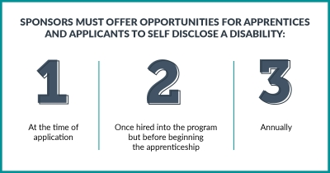
The regulations describe responsibilities of Registered Apprenticeship (RA) program sponsors to ensure apprentices and apprenticeship applicants with disabilities receive equal employment opportunity.
RA program sponsors with five or more apprentices must invite all apprentices and applicants for apprenticeship to voluntarily self-identify whether they have a disability. Voluntary Disability Disclosure Form 671 to self-identify is quite simple. Apprentices and applicants merely indicate: Yes, I have a disability; No, I do not have a disability; or I do not wish to answer on the form. The form does not ask individuals their specific type of disability.
Sponsors must offer the opportunities for apprentices and applicants to self disclose: at the time of application, once hired into the program but before they begin apprenticeship, and annually.
While self-disclosure is voluntary, an individual’s disability status must be kept completely private and can not

