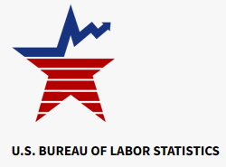

Data on display
Good wages for green work: High-paying careers with an environmental focus

Good wages for green work: High-paying careers with an environmental focus : Career Outlook: U.S. Bureau of Labor Statistics (bls.gov)
Stanislava Ilic-Godfrey and Patricia Tate | April 2023
Good news if you’re considering a green career: there are options that pay well. The chart below shows selected environmentally focused occupations that had a median annual wage above the $45,760 median for all workers in 2021, according to the U.S. Bureau of Labor Statistics. Of the occupations shown, hydrologists—who study how water moves across and through the Earth’s crust—had the highest median annual wage, $84,030 in 2021.
Median annual wage, all o…Selected high-paying occupations that focus on the environment, 2021HydrologistsGeoscientistsMicrobiologistsEpidemiologistsEnvironmental scientists and​specialists, including healthSoil scientists and plant​scientistsZoologists and wildlife​biologistsForestersConservation scientists$0$25,000$50,000$75,000$100,000Hover over bars to view data.​Note: None of the occupations typically requires experience to enter or on-the-job training to attain competency.​Source: U.S. Bureau of Labor Statistics, Employment Projections (projections, education) and ​Occupational Employment Wage Statistic (wages) programs.

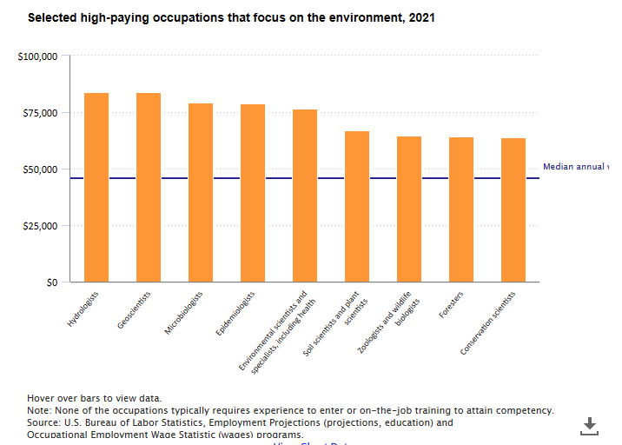

Hydrologists had the smallest worker pool among occupations in the chart, employing 6,800 in 2021; not surprisingly, it’s also projected to have the fewest openings each year, on average, from 2021 to 2031. Environmental scientists, who conduct research and recommend action to protect the environment or human health, is the largest among the occupations shown (80,000 employed in 2021) and is projected to average the most openings each year (about 7,800 over the 2021–31 decade). Occupational openings arise both from job growth and from the need to replace workers who leave their occupation permanently to retire, to enter a different occupation, or for other reasons.
Nearly all the selected occupations typically require a bachelor’s degree to enter. The exception is epidemiologists, which typically requires a master’s degree. Environmental epidemiologists study how elements in the world around us, such as chemicals, affect human health.
Visit the Occupational Outlook Handbook to learn more about what workers do, their pay, job outlook, and more for the occupations in the chart—as well as for hundreds of others.
Stanislava Ilic-Godfrey and Patricia Tate are economists in the Office of Occupational Statistics and Employment Projections, BLS.

SUGGESTED CITATION:
Stanislava Ilic-Godfrey and Patricia Tate, "Good wages for green work: High-paying careers with an environmental focus," Career Outlook, U.S. Bureau of Labor Statistics, April 2023.

