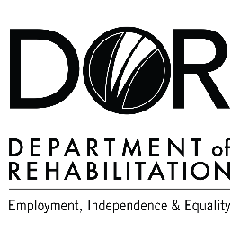

**DEPARTMENT OF REHABILITATION**

Jessica Grove, DSEI Executive Sponsor

Sue Pelbath, DSEI Program Lead

Megan Davis, DSEI Coordinator

Email: [DSEI@dor.ca.gov](mailto:DSEI@dor.ca.gov)

DEMAND SIDE EMPLOYMENT INITIATIVE

**BACKGROUND**

The Department of Rehabilitation (DOR), and the Department of Developmental Services (DDS) received a one-time appropriation of $20 million dollars to fund strategic initiatives to increase the employment opportunities for individuals with disabilities. The DOR has allocated $10 million dollars for its Demand Side Employment Initiative (DSEI), an employer incentive program for businesses to expand or begin hiring people with disabilities. DSEI staff will provide helpful resources, technical support, and assistance with implementing equitable recruitment, training, and retention practices. The DSEI funding will be distributed to small and medium-sized businesses through grants beginning in 2022 through 2024.

**DSEI KEY ELEMENTS FOR BUSINESSES**

**Business Incentives**

* DOR has earmarked over $5 million to incentivize California small to medium-sized businesses to set goals and commitments towards hiring and training individuals with disabilities.
* Small and medium-sized businesses can apply for a grant ranging from $20,000 to $200,000, with the possibility of additional funding in the future.
* This grant will allow businesses to introduce and expand disability inclusive hiring practices.
* Funding is available for, but not limited to, equipment, new hire cost reimbursement, training, consulting services, and physical location improvements.
* Free technical assistance is available to businesses for implementation and support of employing individuals with disabilities.
* DOR is looking for a diverse group of businesses. Have not worked with DOR before? No problem! We encourage all small and medium-sized businesses to apply.

**Campaign to Highlight Participating Businesses**

* DOR has earmarked $2 million for a targeted media and marketing campaign to support the recruitment and employment of individuals with disabilities.
* This strategic multi-media marketing campaign will spotlight the DSEI grant recipient businesses who are champions for disability inclusive hiring in California.

Have a question? Please email us at [DSEI@dor.ca.gov](mailto:DSEI@dor.ca.gov)

