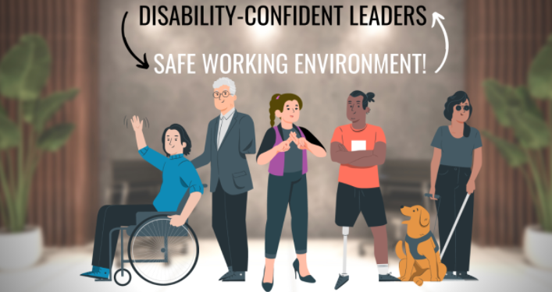

Leaders need to model disability disclosure
Published on September 27, 2021

Vani Seshadri, Global Program Lead - Disability Inclusion, Accenture at Accenture
7 articles Follow
Organizations are working towards building a culture that’s pro-disability inclusive. Some are creating best-in-class initiatives like modern accessible technology and stronger recruitment practices. None of this is of strategic relevance if individuals with disabilities do not feel safe to disclose their condition without worrying about misinterpretation and discrimination.
This problem is further compounded by the fact that not all disabilities are visible. When a disability is visible and known (for example, using a wheelchair), there is less pressure to self-identify. However, when the disability is invisible (like having a learning disability), then a person might prefer to keep it under wraps, for fear of experiencing bias.
The question is not whether people should disclose or not disclose. After all, that’s voluntary. The question is: How can we create the kind of safe and supportive environment where people are encouraged to disclose if they want to?
It starts from the top
Leaders and senior management can play a huge role here in making a shift. A leader with a disability can not only voluntarily disclose it through formal processes. They can also speak about it at every opportunity through multiple channels, and that can have a significant positive impact. It is a proven fact that Leadership Speak sets the tone for organizational culture. Individuals emulate leaders. Therefore, a leader disclosing a disability can dramatically shift internal perception and lay the foundation for others to feel safe about disability disclosure. This will lend stronger credence to programs, and embolden those with disabilities, including those with invisible ones and neurodivergent conditions, to come forward and speak about their disability.
It’s fair to assume that the leaders themselves may be uncomfortable about disclosing their disabilities. Accenture’s research, “Enabling Change” found that 76% of employees and 80% of leaders with a disability are not fully transparent about it. The research goes further to highlight the ill-effects of the gaps and recommends methods to address them.
Here are some leaders with disabilities who have been vocal about it, thus paving the way for a more inclusive culture.
Richard Branson: The founder of the Virgin Group heads an empire that employs 69000 people in 25 countries and earns close to 17 billion USD in a year in revenue. Branson was diagnosed with dyslexia and learning disabilities. He has shared his struggles and advice over the years, has always been open about it, and never hesitated to delegate work when necessary.
Elon Musk: The tech entrepreneur revealed he has Asperger's syndrome while appearing on a television show a few months ago. Going public this way has sparked conversation about business leadership and the autism spectrum. His revelation may change how people deal with autism at work while helping change perceptions about the disability.
Daymond John: When Daymond, CEO of FUBU and investor on the TV show Shark Tank, realized that he had a hearing impairment, he immediately began wearing hearing aids. He uses red ones as he would like people to ask him about them, in turn encouraging others to take the leap and use aids to improve their quality of life.
Caroline Casey: Caroline is an award-winning social entrepreneur and founder of The Valuable 500. She leads from the front. She is a catalyst who has led a tremendous journey to position Disability Inclusion as a Leadership agenda globally. Caroline talks about how she was diagnosed with ocular albinism as a child but knew about it only when she was 17. She explains how her parents did not tell her about it because they didn’t want a stigma attached to her. She’s stepped out to be a very vocal leader, encouraging individuals to disclose their disability, get the accommodations they need, and bring their whole selves to work.
Srikanth Bolla: On the WEF 2021 'Young Global Leaders' list, and the first international blind student at MIT, Srikanth, CEO of Bollant Industries, has a visual impairment. After several obstacles in getting an education, he started a mission to overcome employment barriers and provide sustainable and competitive employment to disabled people, with and without education, in India. 60% of his organization constitutes persons with disabilities.
John Chambers: The Cisco CEO speaks about his struggle with dyslexia. But he also wishes he had made his struggles with reading more public. He says, "You consider it a weakness and you don't share your weaknesses. You don't realize it helps others who have this issue, and your family."
Paul Orfalea: Paul Orfalea founded Kinko’s as a single shop that went on to become a national chain in the US with more than 1000 locations and 25,000 employees. It was then bought by FedEx. Paul never carried a pen and often allowed others to handle his correspondence. He was vocal about having dyslexia and ADHD. In fact, he goes one step further. He says they enabled him to see the world differently.“Lacking the ability to learn by reading,” he says,“I embraced every chance to participate in life. I started businesses, like my vegetable stand. I skipped school to watch my father’s stockbroker at work. I learnt early that I would only get through school with help from a lot of people. I learnt to appreciate people’s strengths and forgive their weaknesses, as I hoped they would forgive mine.”
Bram Cohen: The founder of BitTorrent, a disruptive technology that lets people transfer huge amounts of information over the internet, is vocal about having Asperger’s Syndrome. He talks about how he embraced it. It apparently made him very interested in the world of patterns, puzzles, and computers, and that’s what enabled him to create BitTorrent.
David Neeleman: The founder of JetBlue is famously candid about his ADHD. "One of the weird things about the type of ADHD I have is that if you have something you are really, really passionate about, then you are really, really good about focusing on that thing,” he admits. He also says his ADHD led to him creating JetBlue's e-ticketing system.
As we can see, leaders play a huge role, not just in encouraging others to disclose their disability and get the help they need, but in occasionally telling us inspiring stories where they turned their disabilities to strengths. Imagine the effect this can have on individuals with disabilities, and on the culture we’re trying to build. If more leaders came forward, they could set a powerful example, empower others to share, and raise the collective urgency and credibility around disability inclusion.
Do you know a business leader who has publicly disclosed their disability? How do you think it impacted the way people perceived them? Do you think it helped others feel more comfortable? Share your thoughts around disability disclosure and the role of leaders!

