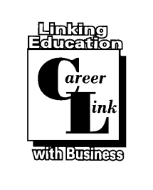
Secondary Transition Curriculum

1. http://teacherspayteachers.com Transition Skills Curriculum M/M & M/S
- Digital download programs from $10-free
- Game of Life –Financial Literacy
- Jobs, Life, & Budgeting
- Typing practice with Printable keyboards
- Class Job Applications
- Career Resume Writing Handouts
- Resume Form FREE
- Career Worksheet Free
- Career Research Project- Planning for my Future
3. www.Youthhood.org M/M
- High School
- Going to school and learning more
- The Job Center
- Learning about work
- The Community Center
- Getting Involved
- The Hangout
- Knowing myself
- Having friends
- Having fun
- Surviving the lunch room
- The Government Center
- Knowing your rights
- Disability rights
- Disability history
- Saying it like it is
- Getting help
- The Health Clinic
- Understanding health
- Being your own advocate
- Understanding insurance
- The Apartment
- Being independent
- Family
- Safety
- Finances
- Hygiene
- Finding my own place
4. http://educationassociates.com/career-development Expensive M/S
5. http://www.collab4youth.org/ncy/cjj.htm (National Collaboration on Youth)
- Teacher publications
6. Pacer .org University of Minnesota (Teacher and Parents site) Transition Updates
- Transition for Youth with Disability
- Workshops
- E-newsletter
- Transition Parent Briefs
8. transitiontowork.com Character Education and Life Skills
9. lifeskills.casey.org/clsa learn provider (Casey Foundation) Life skills M/M
Casey Life Skills (CLS) is a free tool that assesses the behaviors and
competencies youth need to achieve their long term goals. It aims to set youth on
their way toward developing healthy, productive lives.
Examples of the life skills CLS helps youth self-evaluate include:
- Maintaining healthy relationships
- Work and study habits
- Planning and goal-setting
- Using community resources
- Daily living activities
- Budgeting and paying bills
- Computer literacy
- Their permanent connections to caring adults

- Curriculum e-books available for teachers guide and students
10. www.Stanfield.com The Transition Curriculum (3 modules) each module $199
all three $499 M/S
- Volume 1 Personal Management
- Winning with personal power
- Choosing the best career for you
- Maximizing your options
- Advocating for your future
- Volume 2 Career Management
- Using effective communications
- Getting the job for you
- Succeeding as an employee
- Participating in your community
- Volume 3 Get a Life
- Maintaining a healthy life
- Enjoying your leisure time
- Living on your own
- Planning for a happy life
11. Life Centered Education Transition Curriculum (CEC) $599 member $729 non-
member. M/S
- Daily Living Skills
- Self Determination and Interpersonal Skills
- Employment Skills
- Assessment Instruments
- Curriculum Matrix
- Sample Lesson Plans
- LCE Teacher Guide
12. www.gadoe.org?Curriculum-Instrucrtion-and-Assessment/Special-Education-
Services/Pages/Transition-.aspx M/M M/S
- Transition Manual
- Tips for Writing Transition
- Summary of Performance
13. www.pepnet 2.org/transition iTransition (free curriculum on line portfolio)
materials made specifically for deaf and hard to hear (Developed by four
colleges around the country)
- Getting to Know Yourself
- Determining a Career Direction
- Choosing a Post-Secondary Program
- Planning and Applying to Post Secondary Option
14. www.curriculumassociates.com The Transition Skills (Aligns with California
content and four bench mark) M / S
- Assesses Key Transition Areas
- Academic
- Post secondary opportunities
- Independent living
- Community Participation
- Annual Transition Goals and Objectives for the IEP
15. www.nsttac.org (National Secondary Transition Technical Assistance)
- College and Career Ready Standards and Secondary
Planning and Students with Disabilities
- High School Redesign and Secondary Transition Planning for Students with Disabilities
- Tiered Interventions and Secondary Transition Planning for Students with Disabilities
- Universal Design for Learning and Secondary Transition Planning for Students with Disabilities
- Links to All Free Age Appropriate Transition Assessments
- Lesson Plan starts and much more
16. http://transitioncoalition.org/transition Tips for transition with materials that
can be downloaded.
17. http://support.perkins.org/site No more confusion about transition to adult
services.
18. http://www.ecw.edu/cs-acad/stepp/curriculum
19. http://rrti.org/MTPCurriculum.php Model Transition Program-Job Curriculum
Readiness Curriculum (8 modules) Free M / S
20. Learningforlife.org A Boy Scout transition Curriculum M / M
- Managing Finances
- Decision Making
- Vocational Opportunities
- Assessment Instruments
- Curriculum Matrix
- Sample Lesson Plans
- LCE teacher Guide
21. www.ncwd-Youth /Info(National Collaborative on Workforce and Disability) M /M M/S
- Charting The Course: Supporting the Career Development of Youth with Learning Disabilities
- The Guidepost for Success
- The 411 on Disabilities
- Navigating the Road to Work: Basics
22. http://www.rockingham.k12.va.us/rcps_sped/svrp/Section%20VII/Adolescent-
Autonomy-Checklist.pdf Adolescent Autonomy Checklist
23. http://www.integratingstandards.org/dcd/index.html Domain of Independent Living
24. http://beachcenter.org/Books/FullPublications/PDF/ The ArcsSelf
DeterminationScale.pdf Self-Determination Scale M/S
25. www.disability.gov Information for students M/M M/S
- Community Life
- Employment
- Health
- Housing
- Transportation
- And More
26. web.nmusd.us/cms/nothing?d=x&group_id=121899859354 Many websites
attached for transition resources M/M M/S
27. www.foremployers.com Go to Accommodations & Technology-scroll down to
Job Accommodation Examples M/M M/S
28. http://sdsp.uncc.edu/pdf/curriculum_components.pdf Self-Determination
Curricula & Components
29. www.CACareerZone.org M/M M/S
- Assess Yourself
- Explore Job Families
- Make Money Choices
30. www. California RealityCheck.org M/M
31. www.RealGameCalifornia.org M/M
32. www.CACareerZone.org M/M
35. http://autismnow.org/wp-content/uploads/2013/06/Autistic-View-Of-Employment-
Edited.pdf Interesting ideas M/M
This anthology is an honest look at the passions, trials, and tribulations of Autistic self
advocates. It is tempered with advice, rich perspectives, and stories. Our contributors
have shared what it feels like to assess where they’ve been in life and where they
want to go. They have also shared the lessons they have learned. In the following
pages, you’ll discover information about ADA and employment, employment scams,
characteristics of good managers, and tidbits about disclosure and self--- care. Other
subjects include finding work, Vocational Rehabilitation, networking, resumes,
schedules, clear communication, and showcasing your best skills.
36. http://autisticadvocacy.org/wp-content/uploads/2014/01/WTTAC-Adolescent-FINAL-1.pdf M/M
This book will help you to learn about autism. It will teach you what it is and how to live M/S
with it.
37. http://autismnow.org/resources/navigating-college-handbook/#sthash.rUkukpD1.dpuf M/M
This handbook, written by the Autistic Self-Advocacy Network offers tips and suggestions
about several different issues that people with autism and other developmental disabilities may
encounter in college. Topics include accommodations, living in the dorm, independent living,
health and wellness, safety, talking to professors, discussing disability issues with others,
disclosure, and participating in clubs and other social activities.
38. http://www.heath.gwu.edu M/M
The HEATH Resource Center is a web-based clearinghouse that serves as an information
exchange of educational resources, support services and opportunities. The HEATH Resource
Center gathers, develops and disseminates information in the form of resource papers, fact
sheets, website directories, newsletters, and resource materials. HEATH Resource Center is a
collaborative effort among a network of professionals in the areas of disability, counseling,
transition and postsecondary education
39. http://www.frhsd.com:83/curric/images/3/30/LifeSkills.pdf Life Skills Curriculum download
M/S
40. http://www.jumpstart.org/assets/files/2010_J$-BestPracticesMaterials.pdf M/M M/S
Best Practices for Personal Finance Education Materials
41. http://www.gov.pe.ca/photos/original/ed_secondarypl.pdf
- Steps to Transition Planning
- Information Gathering
- Assessments Tools and Forms
- Transition Action Plan
- Student Transition Portfolio
42. http://promotions.usa.gov/odep/essential_job_skills.pdf M/M
- Work Ethic
- Communication
- Problem Solving
43. Career Locker www.careerlocker.com/G_login/moreInfo.asp M/M

The Center on Education and Work, creator and developer of the world class web-based career information system called CareerLocker, is located in the Center for Education and Work (CEW) within the highly ranked School of Education at the University of Wisconsin-Madison. The easy to use, comprehensive website responds to the individual and encourages a self-directed and engaged approach to career development and job-seeking
CareerLocker is designed to help youth and adults:
become aware of themselves and explore how their unique patterns of interests, skills and values can be
applied in their career
become aware of the relevance of how their current educational experiences serve as the foundation
for future career aspirations and life path
develop the job-seeking skills needed to acquire meaningful employment and make successful transitions
into and throughout the world of work
Offering Students and Job-Seekers...
- Self-assessments matching occupations to interests, values, and skills
- Comprehensive information on more than over 700 occupations and overviews of more than 450
specializations
- Career Clusters and Pathways for easy exploration of occupations and a better understanding of how
they are related to one another
- Comprehensive information for more than 3,400 post-secondary schools and over 1,200 programs
of study
- Compare features for occupations and for schools, universities, and colleges
- Reel Life Videos, which includes occupational videos in English and Spanish
- An e-Portfolio that helps individuals to provide evidence of their potential by demonstrating past
accomplishments that can be shared with others
- An Individual Learning Plan to support career and education planning
- A Career Planning Guide for high school students
- Resume and Cover Letter programs
- A Budget Builder program
- Links to job openings
- A Spanish version
Offering Professionals Who Work with Students and Job-Seekers…
- Features, content, and activities that align education and learning with work
- More than 400 Classroom Activities that promote career development and decision-making
skills and are aligned with standards and guidelines
- Extensive customizable reports that reflect individual and organizational use and patterns
- A Message Center feature that allows professionals to post announcements and assignments
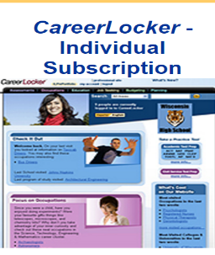
- An advertising-free career resource
- Free Webinars, Online Demos, and Tech Support
Individual Subscriptions $19.95
Business (First 50 Clients $150)
(Additional 50 Clients $75)
Schools (0-249 $700)
(250-999 $1,000)
(1000+ $1,195)
(Prices are good for a one-year subscription from date of purchase)
1-800-862-1071
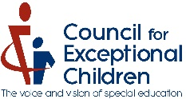
44. Life Centered Education (LCE) Transition Curriculum M/M
CEC is proud to announce the new and entirely online Life Centered Education (LCE) transition curriculum and assessment portal. Discover how LCE can help you better prepare your students for independent and rewarding lives after they finish school.
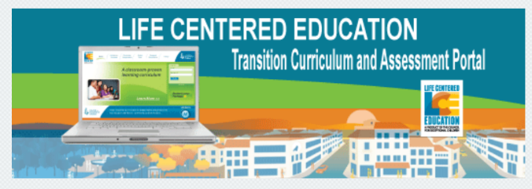
Interested in learning more? Contact our LCE Portal Manager at 703-264-9450 orlce@cec.sped.org to schedule a more in-depth demonstration.

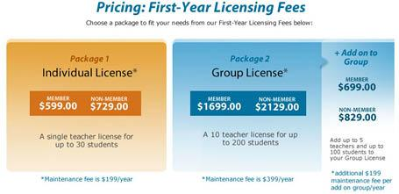
Cost $

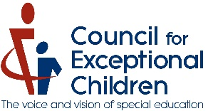
45. 7 Steps for Success M/S

The transition from high school is challenging for any student, but for young adults with
disabilities, it can be even more difficult. But with proper preparation, students can enjoy
success!
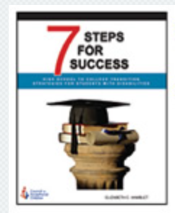
This practical guide explains how the system for accommodations works, describes student’s
rights and responsibilities within that system, and employs the voices of seasoned
professionals and college students to explain the skills & strategies students should develop
while they are in high school to ensure success when they reach college. As a bonus, it also
offers answers to questions students with disabilities frequently ask about disclosing their
disability in the admissions process.

By Elizabeth C. Hamblet. 2011. 163 pages ISBN 0-086586-467-5 #P6041
$32.95
http://imis.cec.sped.org/cec_prod/It

46. Guidance and Career Counselors' Toolkit, Heath Resource Center, George Washington University Graduate
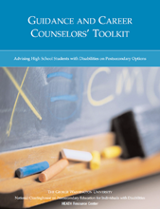
School of Education & Human Development M/M
Advising High School Students with Disabilities on Postsecondary Options
This 192 page resource contains answers to counselors' most frequently
asked questions about postsecondary opportunities for students with
disabilities. Students and their families are encouraged use the toolkit to
help guide their transition planning for college and career. Click here to
access the Toolkit online. It has been vetted
by the U.S. Department of Education.

FREE

Moderate/Severe M/ S
Mild/Moderate M/M
IUSD R. Menn, L. O’Neal, 1-2016, 2-12-14

