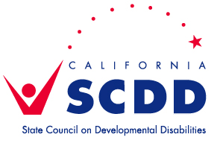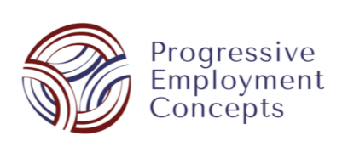

Join the State Council on Developmental Disabilities’ Sacramento, North Bay, & San Diego Regional Offices and Progressive Employment Concepts for:

Work More, Earn More!
Learn about the Ticket to Work Program and how you can work more while protecting your Social Security and health benefits

Thursday, February 18, 2021 ~ 6:00pm-8:00pm
Register in advance for this free Zoom training at: https://bit.ly/35rarVV
All are welcome!

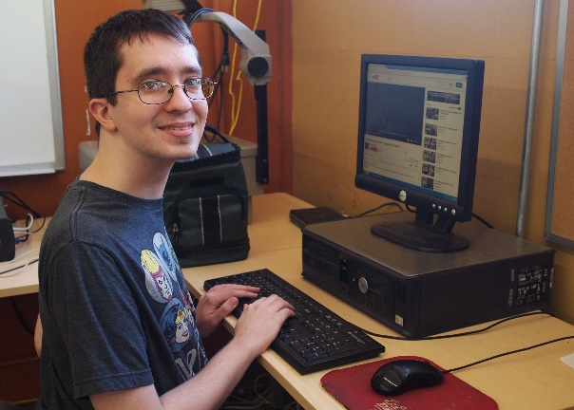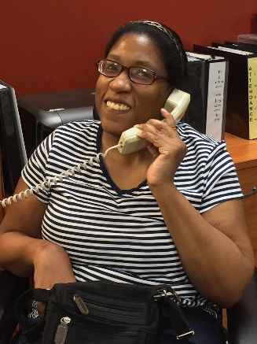

Pam Haney, MSW, Employment Developer and Community Work Incentives Counselor with Progressive Employment Concepts, will provide information and resources for people of all skill levels to work and earn substantially. All people with disabilities can gain competitive integrated employment (CIE) with the right supports. We will discuss Customized Employment and how to ask for services, working while receiving Social Security benefits, and the Ticket to Work program. This information is applicable throughout California.

Self-advocates and business owners will speak about supports through customized employment and what it has meant for them, their families, or their business.

If you have a question or need accommodations, please contact Sonya Bingaman at least 5 days in advance at sonya.bingaman@scdd.ca.gov .
Recordings of this & previous trainings on a variety of topics can be found at www.youtube.com/CalSCDD or https://scdd.ca.gov/sacramento/

