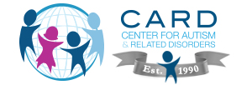

Leading the Way in the Successful Treatment of Autism

The Center for Autism and Related Disorders (CARD) is one of the world's largest organizations using applied behavior analysis (ABA) in the treatment of autism spectrum disorder.

CONTACT US TOLL FREE (PARA AYUDA EN ESPAÑOL): 1-855-345-CARD (2273)

- Home
- About Us
- Locations
- Services»

- Programs»

- Research
- Resources
- Press
- Events
- Careers»

- Contact Us
- Enroll
- ABA Therapy
- Choosing a Provider
- Insurance
- CARD Level I
- CARD Level II
- How to Enroll
- Remote Consultations

ABA RESOURCES: WHAT IS ABA?
Behavior Analysis is the scientific study of behavior. Applied Behavior Analysis (ABA) is the application of the principles of learning and motivation from Behavior Analysis, and the procedures and technology derived from those principles, to the solution of problems of social significance. Many decades of research have validated treatments based on ABA.
The Report of the MADSEC Autism Task Force (2000) provides a succinct description, put together by an independent body of experts:
Over the past 40 years, several thousand published research studies have documented the effectiveness of ABA across a wide range of:
- populations (children and adults with mental illness, developmental disabilities and learning disorders)
- interventionists (parents, teachers and staff)
- settings (schools, homes, institutions, group homes, hospitals and business offices), and
- behaviors (language; social, academic, leisure and functional life skills; aggression, selfinjury, oppositional and stereotyped behaviors)
Applied behavior analysis is the process of systematically applying interventions based upon the principles of learning theory to improve socially significant behaviors to a meaningful degree, and to demonstrate that the interventions employed are responsible for the improvement in behavior (Baer, Wolf & Risley, 1968; Sulzer-Azaroff & Mayer, 1991).

SOCIALLY SIGNIFICANT BEHAVIORS
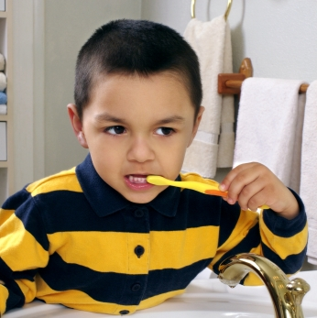"Socially significant behaviors" include reading, academics, social skills, communication, and adaptive living skills. Adaptive living skills include gross and fine motor skills, eating and food preparation, toileting, dressing, personal self-care, domestic skills, time and punctuality, money and value, home and community orientation, and work skills.

ABA methods are used to support persons with autism in at least six ways:
- to increase behaviors (eg reinforcement procedures increase on-task behavior, or social interactions);
- to teach new skills (eg, systematic instruction and reinforcement procedures teach functional life skills, communication skills, or social skills);
- to maintain behaviors (eg, teaching self control and self-monitoring procedures to maintain and generalize job-related social skills);
- to generalize or to transfer behavior from one situation or response to another (eg, from completing assignments in the resource room to performing as well in the mainstream classroom);
- to restrict or narrow conditions under which interfering behaviors occur (eg, modifying the learning environment); and
- to reduce interfering behaviors (eg, self injury or stereotypy).
ABA is an objective discipline. ABA focuses on the reliable measurement and objective evaluation of observable behavior.

RELIABLE MEASUREMENT
Reliable measurement requires that behaviors are defined objectively. Vague terms such as anger, depression, aggression or tantrums are redefined in observable and quantifiable terms, so their frequency, duration or other measurable properties can be directly recorded (Sulzer-Azaroff & Mayer, 1991). For example, a goal to reduce a child's aggressive behavior might define "aggression" as: "attempts, episodes or occurrences (each separated by 10 seconds) of biting, scratching, pinching or pulling hair." "Initiating social interaction with peers" might be defined as: "looking at classmate and verbalizing an appropriate greeting."
ABA interventions require a demonstration of the events that are responsible for the occurrence, or non-occurrence, of behavior. ABA uses methods of analysis that yield convincing, reproducible, and conceptually sensible demonstrations of how to accomplish specific behavior changes (Baer & Risley, 1987). Moreover, these behaviors are evaluated within relevant settings such as schools, homes and the community. The use of single case experimental design to evaluate the effectiveness of individualized interventions is an essential component of programs based upon ABA methodologies.
This process includes the following components:
- selection of interfering behavior or behavioral skill deficit
- identification of goals and objectives
- establishment of a method of measuring target behaviors
- evaluation of the current levels of performance (baseline)
- design and implementation of the interventions that teach new skills and/or reduce interfering behaviors
- continuous measurement of target behaviors to determine the effectiveness of the intervention, and
- ongoing evaluation of the effectiveness of the intervention, with modifications made as necessary to maintain and/or increase both the effectiveness and the efficiency of the intervention. (MADSEC, 2000, p. 21-23)
As the MADSEC Report describes above, treatment approaches grounded in ABA are now considered to be at the forefront of therapeutic and educational interventions for children with autism. The large amount of scientific evidence supporting ABA treatments for children with autism have led a number of other independent bodies to endorse the effectiveness of ABA, including the U.S. Surgeon General, the New York State Department of Health, the National Academy of Sciences, and the American Academy of Pediatrics (see reference list below for sources).

DISCRETE TRIAL TRAINING
Discrete trial training (DTT) is a particular ABA teaching strategy which enables the learner to acquire complex skills and behaviors by first mastering the subcomponents of the targeted skill. For example, if one wishes to teach a child to request a a desired interaction, as in "I want to play," one might first teach subcomponents of this skill, such as the individual sounds comprising each word of the request, or labeling enjoyable leisure activities as "play." By utilizing teaching techniques based on the principles of behavior analysis, the learner is gradually able to complete all subcomponent skills independently. Once the individual components are acquired, they are linked together to enable mastery of the targeted complex and functional skill. This methodology is highly effective in teaching basic communication, play, motor, and daily living skills.
Initially, ABA programs for children with Autism utilized only (DTT), and the curriculum focused on teaching basic skills as noted above. However, ABA programs, such as the program implemented at CARD, continue to evolve, placing greater emphasis on the generalization and spontaneity of skills learned. As patients progress and develop more complex social skills, the strict DTT approach gives way to treatments including other components.
Specifically, there are a number of weaknesses with DTT including the fact the DTT is primarily teacher initiated, that typically the reinforcers used to increase appropriate behavior are unrelated to the target response, and that rote responding can often occur. Moreover, deficits in areas such "emotional understanding," "perspective taking" and other Executive Functions such as problem solving skills must also be addressed and the DTT approach is not the most efficient means to do so.
Although the DTT methodology is an integral part of ABA-based programs, other teaching strategies based on the principles of behavior analysis such as Natural Environment Training (NET) may be used to address these more complex skills. NET specifically addresses the above mentioned weaknesses of DTT in that all skills are taught in a more natural environment in a more "playful manner." Moreover, the reinforcers used to increase appropriate responding are always directly related to the task (e.g., a child is taught to say the word for a preferred item such as a "car" and as a reinforcer is given access to the car contingent on making the correct response). NET is just one example of the different teaching strategies used in a comprehensive ABA-based program. Other approaches that are not typically included in strict DTT include errorless teaching procedures and Fluency-Based Instruction.
At CARD all appropriate teaching approaches based on the well grounded principles of applied behavior analysis are utilized.
References
Baer, D., Wolf, M., & Risley, R. (1968). Some current dimensions of applied behavior analysis. Journal of Applied Behavior Analysis, 1, 91 - 97.
Baer, D., Wolf, M., & Risley, R. (1987). Some still-current dimensions of applied behavior analysis. Journal of Applied Behavior Analysis, 20, 313 - 327.
Maine Administrators of Services for Children with Disabilities (MADSEC) (2000). Report of the MADSEC Autism Task Force.
Myers, S. M., & Plauché Johnson, C. (2007). Management of children with autism spectrum disorders.Pediatrics, 120, 1162-1182.
National Academy of Sciences (2001). Educating Children with Autism. Commission on Behavioral and Social Sciences and Education.
New York State Department of Health, Early Intervention Program (1999). Clinical Practice Guideline: Report of the Recommendations: Autism / Pervasive Developmental Disorders: Assessment and Intervention for Young Children (Age 0-3 years).
Sulzer-Azaroff, B. & Mayer, R. (1991). Behavior analysis for lasting change. Fort Worth, TX : Holt, Reinhart & Winston, Inc.
US Department of Health and Human Services (1999). Mental Health: A Report of the Surgeon General.Rockville, MD: U.S. Department of Health and Human Services, Substance Abuse and Mental Health Services Administration, Center for Mental Health Services, National Institutes of Health, National Institute of Mental Health.

ABA RESOURCES: CHOOSING AN ABA PROVIDER
In the sea of ABA providers, parents often wonder which providers are the best for their children. This is a very real and important concern. Unfortunately, there are numerous "providers" claiming to have expertise in the field of Autism treatment. However, although a provider may have ABA training, it is important to ensure that they also have expertise with this client population and are able to develop individualized programs beginning with simple imitation and concluding with complex social understanding.
When evaluating ABA programs parents should ascertain whether the following program guidelines are in place:

INDIVIDUALIZED PROGRAMMING
✓ Does the provider work within the child's areas of strength?
✓ Are adaptations to the curriculum made when needed?
✓ Avoidance of "cook book" programming: Beware of Sd sheets copied from the Maurice or other similar books
✓ Does the agency incorporate the latest research findings into their treatment plans?

EMPHASIS ON GENERALIZATION
✓ Does generalization work begin immediately?
✓ Is there an emphasis to generalize skills across people?
✓ Is there an emphasis to generalize the way instructions are given?
✓ Is there an emphasis to generalize skills across learning environments?
✓ Is there a push to transition to a naturally occurring reinforcement schedule?

SUPERVISION
✓ Is regular supervision considered crucial to the program success?
✓ Are behavioral excesses and reductive strategies reviewed at each supervisory meeting?
✓ Is school progress reviewed and are there shadowing goals outlined?
✓ Are all drills reviewed and demonstrated at each supervisory meeting?
✓ Are the children's programs adapted to their individual needs?
✓ Are the necessary referrals provided when needed?

INTENSITY & CONSISTENCY
✓ Are the hours recommended consistent with research findings?
✓ Are steps taken to ensure consistency?
→ Parent / Nanny / Extended Family Training
→ Frequent Consultation with School Staff
→Frequent Consultation with other providers

ACKNOWLEDGMENT OF BIOMEDICAL FACTORS IMPACTING TREATMENT
✓ Are parents encouraged to explore medical treatments?
✓ Is information regarding dietary changes provided?
✓ Are pre-screened referrals provided when necessary?

SPECIALIZED PROGRAMS FOR PARTICULAR LEARNERS
✓ Are Social Skills Training / Executive Function Training / Theory of Mind Work part of the program?
✓ Is adequate programming for non-verbal children available if needed?
✓ Are other programs brought in to aide the child's pattern of acquisition (PECS, Social Stories, etc.)

ABA RESOURCES: INSURANCE COVERAGE
​Historically, Applied Behavior Analysis (ABA) has not been covered by most insurance plans. The common rationale for this was that ABA was not scientifically proven effective for the treatment for Autism. As time has passed, ABA has been proven to be one of the most effective treatments for Autism, and because of that, an increasing number of large employers have added ABA therapy benefits to their health care plans. Parents should check with their Human Resources department to find out if their employer is one of these companies, or to ask if such a benefit can be added. If enough people ask, they might just add it.
As of April 2011, there are 25 states that mandate coverage for ABA therapy for certain health plans, and more states are coming on board each year. For a list of these states, or to find out what is happening in your state and to learn how you can help, please visit Autism Votes and click on your state. Autism Votes is part of Autism Speaks and is a great resource for news and information about autism legislation.
If you live in one of the states that does not mandate coverage (or if your plan is not subject to the state mandate) and you have received a coverage denial or claim rejection, you can appeal this decision. Contact your insurance company to find out how their appeal process works. Some families have appealed and won. There's a chance you could be one of those families!

THERE IS HOPE ON THE HORIZON!
As it is written now, the Patient Protection and Affordable Care Act (PPACA), commonly known as ObamaCare, will provide coverage for behavioral therapies, including ABA, for most insurance plans beginning in 2014. Stay Tuned!!!!

THERAPY PROGRAMS: CARD I

​Lesson Areas and Sample Targeted Skills for Individuals 0 - 8
Following the principles of Applied Behavior Analysis, we developed a treatment approach for children with autism, up to age eight, that focuses on minimizing challenging behaviors and maximizing skill acquisition. Once new behaviors are mastered, we focus on generalization with the goal of transitioning each child into the mainstream educational system. If necessary, we also provide school shadowing services so children have the support they need in the classroom.

Challenging Goals; Trackable Progress
We teach self-help and safety skills, build language and communication, as well as an array of advanced skills such as theory of mind, social skills, and executive functioning. With the input of parents and the child’s caregivers, we set challenging goals for our team and the child and track progress on each skill domain carefully. The chart below gives more details about our curriculum areas.
The program is developed and managed by a highly trained CARD supervisor who tailors the program to each child’s needs. A team of therapists implements the plan and participates in training and team meetings to ensure consistency. The entire treatment team, including all caregivers (mom, dad, grandparents, and siblings) is invited to participate in regular “clinic meetings” designed to review the child’s progress, train on new techniques and add lessons to the program.
For more information about the CARD I program for your child, please contact one of our offices.
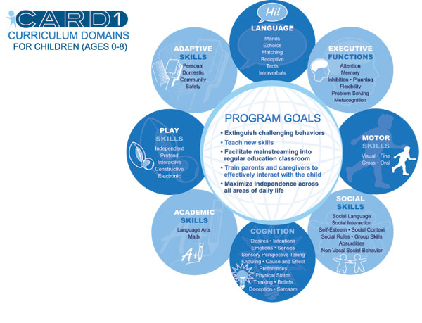

THERAPY PROGRAMS: CARD 2
​Lesson Areas and Sample Targeted Skills for Individuals 9-21
Building from the successes of the CARD I program for children up to age eight, we developed the CARD II program which is tailored to the special needs of individuals ages eight to 21. The broad scope of the curriculum allows us to assist students with a wide range of skills and deficits.
The CARD II program is flexible and can be tailored to individuals with different needs. Specifically, the program can assist students whose families require support managing problem behaviors, as well as teach basic communication skills and adaptive skills (i.e., toileting, dressing, and making meals). It can also assist students who are mildly affected and may need assistance only to acquire more complex social skills and apply them with their peers in their natural environments.

The CARD II Goal
While each student will come to us with unique needs, we have developed a set of long-term goals that are important for all students to work toward achieving. The CARD II goal is to teach independence skills, appropriate social activities and relationship building, as well as many other skills.
Students in the CARD II population typically have less time for intervention, making it increasingly important that we deliver a targeted curriculum with carefully prioritized skill targets. The CARD II curriculum is based upon a specific skill hierarchy which ensures that each student fluently possesses the personally relevant skills within each curricular domain before moving on to the next domain in the hierarchy. Each of the skill domains are comprised of skill targets that will assist the student in achieving his or her long term-goals. The chart below gives more details about the CARD II program goals and targeted skills taught.
For more information about the CARD II program for your child, please contact one of our offices.
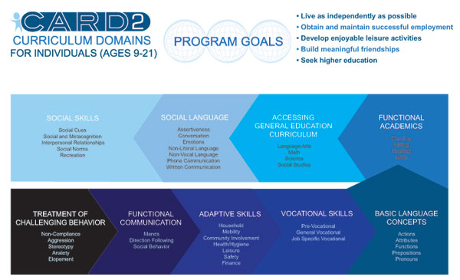

THERAPY PROGRAMS: ENROLLMENT PROCESS

Getting Started with CARD
APPLY ONLINE NOW
- Contact the nearest CARD office and provide your name, telephone number, and mailing address.
- Information regarding CARD, our services, providers and rates will be mailed to you within one week.
- After reviewing the information package, contact the nearest CARD office to schedule an Initial Assessment. During the Initial Assessment, a behavioral observation of the child and an interview with the parents will be conducted. The appropriateness of this type of therapy, the recommended number of hours and other information regarding biomedical treatment, testing, and adjunct therapies will be discussed.
- Complete and return the CARD evaluation form provided at intake and send us copies of all relevant recent test results, IEP records, and reports.
- Once we have received the information, a report will be generated. The report will summarize our findings at intake and will reiterate our recommendations for services required for your child.
- Forward our report to the appropriate funding agency (school district, regional center, insurance company, health department).
- Once funding has been secured (or if you decide to start on a private pay basis), your child's file will be assigned to a supervisor and you will be contacted to schedule your first clinic.
- At your first clinic, you will meet the therapists who have been chosen to work with your child and your child's initial program will be demonstrated. Parent training will be scheduled for you and therapy will commence immediately following your initial clinic.

Workshop Services
If you are outside of a 50 mile radius of one of our offices and would like to have assistance in establishing an in-home on-going CARD supervision based program for your child, please follow the procedure listed below:

Getting Started
For questions or to request a Workshop Application Packet:
- Contact the Workshop Department at (818) 345-2345
- Submit a Request Form online via the CARD website www.centerforautism.com
- Email the Workshop Department at info@centerforautism.com
- Fax the Workshop Department at (818) 758-8015
- Submit a request by mail:
CARD Headquarters
c/o Workshop Department
19019 Ventura Blvd., Suite 300
Tarzana, CA 91356
Our CARD Workshop staff is ready to assist you and answer all of your questions.

REMOTE CONSULTATIONS
CARD Workshop Services are available to families who live at least 50 miles from the closest CARD site or reside in a state or country without a CARD site. This service allows families to receive the benefits of a CARD-supervised program without living near one of our sites. CARD consultants travel to families, provide initial training to the parents and their hired staff, and then put into place a CARD program for the child. The consultant also provides ongoing supervision of the child's CARD program and continues to provide training to the parents and their staff as needed.

Individualized CARD Program
- Ongoing CARD Supervision
- CARD In-Home Visits
- Ongoing CARD Assessment
- Parent Training
- Staff Training
- Collaboration with Adjunct Therapy Providers
- Collaboration with Third-Party Funding Authorities
- Development of a Client Base for a Potential CARD Site
CARD Workshop Consultation involves a balance between working directly with the child and his/her treatment team, program design, and documentation of progress. Services include:
- Face-to-face visits
- Training
- Team Meetings (home/school)
- Phone/Video Conferences
- 1:1 Probe Sessions
- Observation
- Program Reviews and Updates
- Program Design
- Therapy Critique
- Report Writing
- Follow-up Correspondence (via fax, email, or mail)
For questions or to request a workshop application packet to be sent out to you:
- Contact the Workshop Department at (818) 345-2345, or
- Email your request to workshop@centerforautism.com
- Join our Mailing List

- Site Map
- Search
- Sign In
- Careers
- DDS 916-654-1987
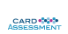

CARD - An Ever Growing Family
As a core value of the CA mission, CARD is always looking to grow our family. If you are interested in CARD acquiring, developing and/or partnering with your agency, simply send an e-mail to mergers@centerforautism.com
© CENTER FOR AUTISM AND RELATED DISORDERS, LLC. ALL RIGHTS RESERVED.

