Six Core Elements of Transition
Transitioning Youth
to Adult Health Care
for use by Medical and Social Service Providers

Table of Contents
Preamble | 1
Introduction to Each of the Six Core Elements | 2
Core Element Samples
- Transition Policy
- Sample Transition Policy | 3
- Transition Tracking and Monitoring
- Sample Individual Transition Flow Sheet | 4
- Sample Transition Registry | 5
- Transition Readiness
- Sample Transition Readiness Assessment for Youth | 6
- Sample Transition Readiness Assessment for Parents/Caregivers | 7
- Transition Planning
- Sample Plan of Care | 8
- Sample Medical Summary and Emergency Care Plan | 9
- Transfer of Care
- Sample Transfer Letter | 11
- Transfer Completion
- Sample Health Care Transition Feedback Survey for Youth | 12
- Sample Health Care Transition Feedback Survey for Parents/Caregivers | 13

Got Transition and the Orange County Care Coordination Collaborative for Kids (OCC3) are pleased to share this package of the Six Core Elements of Transition for use by medical and social service providers to benefit all youth, including those with special needs, as they transition from pediatric to adult-centered health care. Transition consists of joint planning with youth and parents/caregivers to foster development of self-care skills and active participation in decision-making. It also consists of assistance in identifying adult providers and ensuring a smooth transfer to adult-centered care with current medical information.
Recognizing and responding to the diversity among youth, young adults and their families is essential to the transition process. This diversity may include but is not limited to differences in culture, race, ethnicity, languages spoken, intellectual abilities, gender, sexual orientation, and age. Since implementation of the Six Core Elements depends so much on communication, agencies and practices should use appropriate oral and written communications, including interpretation and translation services and health literacy supports as needed. In addition, engaging youth and parents/caregivers from various cultural backgrounds in the development and evaluation of a transition quality improvement process is important.
The Six Core Elements of Transition define the basic components of transition support and the linked sample tools in this package provide tested means for transitioning youth to adult providers and services. Originally developed in 2009, this updated version incorporates the results of recent transition learning collaborative experiences in several states, an examination of transition innovations in the United States and abroad, and reviews by over 50 pediatric and adult health care professionals and youth and family experts.
To implement the Six Core Elements, a quality improvement approach is recommended. Plan-do-study-act (PDSA) cycles provide a useful way to incrementally adopt the Six Core Elements as a standard part of care for youth and their families. Leadership support from the organization is critical as well. Oftentimes, practices decide to begin with a subset of youth in order to pilot the changes needed for transition. Sample tools that can be customized for use are available in this package and on www.GotTransition.org.
Got Transition and OCC3 welcome your comments and feedback on the Six Core Elements of Transition. Thank you for your interest in the successful health care transitions of youth and young adults from pediatric to adult-centered care.

Six Core Elements of Transition
1. Transition Policy
- Develop a transition policy/statement with input from youth and families that describes the organization’s approach to transition, including privacy and consent information.
- Educate all staff about the approach to transition, the policy/statement, the Six Core Elements, and distinct roles of the youth, family, and staff in the transition process, taking into account cultural preferences.
- Post policy and share/discuss with youth and families, beginning at age 14, and regularly review (at least annually) as part of ongoing care. A sample letter is attached, but this could also be sent via your patient portal, or on a poster in your waiting room.
2. Transition Tracking and Monitoring
- Establish criteria and a process for identifying transitioning youth and enter their data into a registry.
- Utilize individual flow sheet or registry to track youth’s transition progress with the Six Core Elements.
- Incorporate Six Core Elements into clinical care process, using EHR if possible.
3. Transition Readiness
- Conduct regular transition readiness assessments, at least annually, beginning at age 14
- Jointly develop goals and prioritized actions with youth and parent/caregiver and document regularly in a plan of care. Assign homework, as parents are great teachers. You may need to follow up sooner rather than waiting a year, especially with goal-setting.
4. Transition Planning
- Develop and regularly update the plan of care (at least annually), including readiness assessment findings, goals and prioritized actions, medical summary and emergency care plan, and, if needed, legal documents.
- Prepare youth and parent/caregiver for adult approach to care at age 18, including legal changes in decision-making and privacy and consent, self-advocacy, and access to information.
- Determine need for decision-making supports for youth with intellectual challenges and make referrals to legal resources.
- Plan with youth and parent/caregiver for optimal timing of transfer. If multiple providers are involved, discuss optimal timing for each.
- Obtain consent from youth/guardian for release of medical information.
- Assist youth in identifying an adult provider and communicate with selected provider about pending transfer of care.
- Provide linkages to insurance resources, self-care management information, and culturally appropriate community supports.
5. Transfer of Care
- Confirm date of first adult provider appointment.
- Transfer young adult when his/her condition is stable.
- Complete transfer package, including final transition readiness assessment, plan of care with transition goals and pending actions, medical summary and emergency care plan, and, if needed, legal documents, and additional provider records.
- Prepare letter with transfer package, send to adult practice, and confirm adult practice’s receipt of transfer package.
- Confirm with adult provider the pediatric provider’s responsibility for care until young adult is seen in adult setting.
6. Transfer Completion
- Contact young adult and parent/caregiver 3 to 6 months after last pediatric visit to confirm transfer of responsibilities to adult providers and elicit feedback on experience with transition process.
- Communicate with adult practice confirming completion of transfer and offer consultation assistance, as needed.
- Build ongoing and collaborative partnerships with adult providers.

[Pediatric Provider Name] wants to help our patients (clients) make a smooth transition from pediatric to adult care. This means working with youth, beginning at age 14, and their families, to get ready for the change from “pediatric” care, where parents make most decisions to “adult” care, where young adults make the decisions. This means that we will spend time during the visit with the teen without the parent there. This will help teens understand their health and well-being and support them in becoming more independent with their own care. We will also help you prepare for the ways adult care is different, and how the resources to help you stay healthy might change.
At age 18, youth legally become adults. We know that many of our young adult patients continue to involve their families in decisions. We will be able to talk to family members about personal health information only with the young adult’s permission. If the youth has a condition that means that they cannot make their own decisions, then we would want parents/caregivers to think about the role they would have in making decisions.
We will work with youth and families to transfer to an adult provider and recommend that this transfer happens before age 21. We will help with this transfer process, including help finding a provider who sees adults, sending records, and talking with the adult provider about the needs of our patients.
As always, if you have any questions or concerns, please feel free to ask us.

Name: ______________ Date of Birth: ___________

Primary Diagnosis/Reason for Services: ______________ Transition Complexity: ______________
Low, moderate, or high
Transition Policy
-Practice policy on transition discussed/shared with youth and parent caregiver _________
Date
Transition Readiness Assessment
-Conducted transition readiness assessment _________ _________ _________ _________ _________
Date Date Date Date Date
-Included transition goals and developed a plan of care _________ _________ _________ _________ __________
Date Date Date Date Date
Medical Summary and Emergency Plan
-Updated and Shared medical summary and emergency plan _________ _________ _________
Date Date Date
Adult Model of Care
-Decision-making changes, privacy, and consent in adult care discussed with youth and parent/caregiver (if needed, discussed plans for supported decision-making) _________
Date
-Timing of transfer discussed with youth and parent/caregiver _________
Date
-Adult Primary Care Provider Selected ____________________________ ____________________ __________
Name/Clinic Phone First Appt Completed
-Insurance Plan ________________________________ Medical Group ________________________________________

-Other adult providers identified: _________________________________________________________________________
Transfer of Care
-Prepared transfer package, if desired, which may include:
- Plan of care/Health Summary
- Legal documents, if needed
- Additional provider records, if needed
-Sent transfer package _________
Date
-Communicated with adult provider about transfer _______________________ _________
Name Date
-Confirmed transfer, elicited feedback from young adult after transfer from pediatric care _________
Date(s)

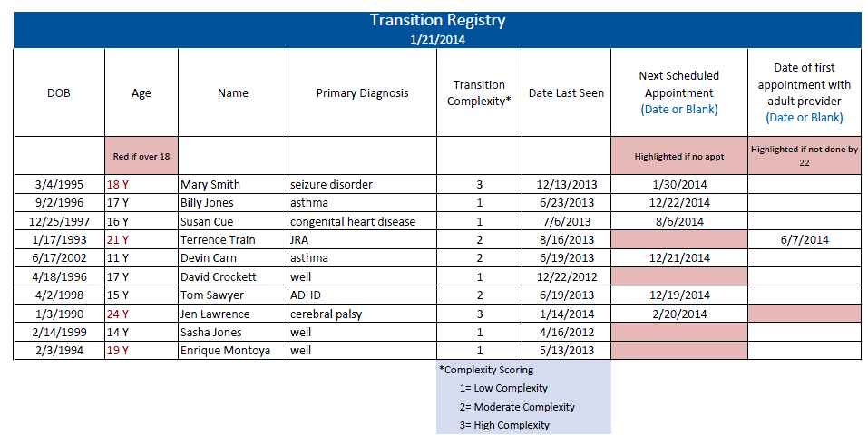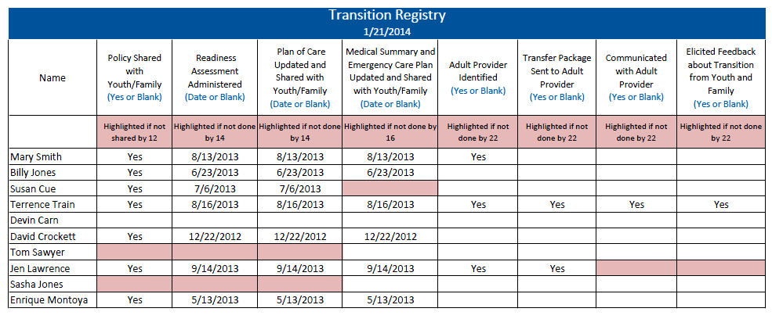

Please fill out this form to help us see what you already know about your health and how to use health care and other resources, and the areas that you need to learn more about. If you need help completing this form, please ask your parent/caregiver.
Date: Name: Date of Birth:
Transition Importance and Confidence On a scale of 0 to 10, please circle the number that best describes how you feel right now.

How important is it to you to prepare for/change to an adult provider before age 21?
0 (not) | 1 | 2 | 3 | 4 | 5 | 6 | 7 | 8 | 9 | 10 (very)
How confident do you feel about your ability to prepare for/change to an adult provider?
0 (not) | 1 | 2 | 3 | 4 | 5 | 6 | 7 | 8 | 9 | 10 (very)

My Health & Wellbeing Please check the box that applies to you right now. | Yes, I know this | I need to learn | Someone needs to do this… Who?
I know my medical and social service needs, condition, and treatment. | ☐ | ☐ | ☐
I can explain my needs to others. | ☐ | ☐ | ☐
I know my symptoms, including ones that I quickly need to see a doctor for. | ☐ | ☐ | ☐
I know what to do in case I have a medical emergency. | ☐ | ☐ | ☐
I know my own medicines, what they are for, when I need to take them and what happens  if I don’t. | ☐ | ☐ | ☐
I know my allergies to medicines and medicines I should not take. | ☐ | ☐ | ☐
I carry important health information with me every day (e.g. insurance card, allergies, medications, emergency contact information, and medical summary). | ☐ | ☐ | ☐
I understand how health care privacy changes at age 18 when I am legally an adult. | ☐ | ☐ | ☐
I know the names of services I use, how to reach them, and why I need them. | ☐ | ☐ | ☐
Using Health Care
I know or I can find my doctor’s or other provider’s phone number. | ☐ | ☐ | ☐
I make my own appointments. | ☐ | ☐ | ☐
Before a visit to a provider, I think about questions to ask and write them down. | ☐ | ☐ | ☐
I have a way to get to my visits. | ☐ | ☐ | ☐
I know to show up 15 minutes before the visit to check in. | ☐ | ☐ | ☐
I know where to go to get care when the provider’s office is closed. | ☐ | ☐ | ☐
I have a file at home for my medical information or access to my electronic record | ☐ | ☐ | ☐
I have a copy of my current plan of care. | ☐ | ☐ | ☐
I know how to fill out medical forms and how to use health insurance. | ☐ | ☐ | ☐
I know how to get referrals to other providers. | ☐ | ☐ | ☐
I know where my pharmacy is and how to refill my medicines. | ☐ | ☐ | ☐
I know where to get blood work or x-rays if my doctor orders them. | ☐ | ☐ | ☐
I have a plan so I can keep my health insurance after 18 or older. | ☐ | ☐ | ☐
My family and I have discussed my ability to make health care decisions at age 18. | ☐ | ☐ | ☐

Please fill out this form to help us see what your child already knows about his or her health and wellbeing and the areas that you think he/she needs to learn more about. After you complete the form, compare your answers with the form your child has completed. Your answers may be different. We will help you work on some steps to increase your child’s health care skills.
Date: Name: Date of Birth:
Transition Importance and Confidence On a scale of 0 to 10; please circle the number that best describes how you feel right now.

How important is it for your child to prepare for/change to an adult provider before age 21?
0 (not) | 1 | 2 | 3 | 4 | 5 | 6 | 7 | 8 | 9 | 10 (very)
How confident do you feel about your child’s ability to prepare for/change to an adult provider?
0 (not) | 1 | 2 | 3 | 4 | 5 | 6 | 7 | 8 | 9 | 10 (very)

My Child’s Health & Wellbeing Please check the box that applies to your child right now. | Yes, he/she knows this | He/she needs to learn | Someone needs to do this… Who?
My child knows his/her medical and other service needs. | ☐ | ☐ | ☐
My child can explain his/her needs to others. | ☐ | ☐ | ☐
My child knows his/her symptoms including ones that he/she quickly needs to see a doctor for. | ☐ | ☐ | ☐
My child knows what to do in case he/she has a medical emergency. | ☐ | ☐ | ☐
My child knows his/her own medicines, what they are for, and when he/she needs to take them. | ☐ | ☐ | ☐
My child knows his/her allergies to medicines and medicines he/she should not take. | ☐ | ☐ | ☐
My child carries important health information with him/her every day (e.g. insurance card, allergies, medications, emergency contact information, and medical summary). | ☐ | ☐ | ☐
My child knows names and contact information for services he/she uses. | ☐ | ☐ | ☐
My child understands how health care privacy changes at age 18. | ☐ | ☐ | ☐
Using Care
My child knows or can find his/her provider’s phone number. | ☐ | ☐ | ☐
My child makes his/her own appointments. | ☐ | ☐ | ☐
Before a visit, my child thinks about questions to ask. | ☐ | ☐ | ☐
My child has a way to get to his/her appointments. | ☐ | ☐ | ☐
My child knows to show up 15 minutes before the visit to check in. | ☐ | ☐ | ☐
My child knows where to go to get medical or other care when the provider’s office is closed. | ☐ | ☐ | ☐
My child has a file at home for his/her medical information. | ☐ | ☐ | ☐
My child has a copy of his/her current plan of care. | ☐ | ☐ | ☐
My child knows how to fill out medical forms. | ☐ | ☐ | ☐
My child knows how to get referrals to other providers. | ☐ | ☐ | ☐
My child knows where his/her pharmacy is and how to refill his/her medicines. | ☐ | ☐ | ☐
My child knows where to get blood work or x-rays if his/her doctor orders them. | ☐ | ☐ | ☐
My child has a plan to keep his/her health insurance after ages 18 or older. | ☐ | ☐ | ☐
My child and I have discussed his/her ability to make his/her own health care decisions at age 18. | ☐ | ☐ | ☐
My child and I have discussed a plan for supported decision-making, if needed. | ☐ | ☐ | ☐

Instructions: This sample plan of care is a written document developed jointly with the transitioning youth to establish priorities and a course of action that integrates health and personal goals. Motivational interviewing and strength-based counseling are key approaches in developing a collaborative process and shared decision-making. Information from the transition readiness assessment can be used to guide the development of health goals. The plan of care should be dynamic and updated regularly and sent to the new adult provider as part of the transfer package along with the latest transition readiness assessment, medical summary and emergency care plan, and, if needed, a condition fact sheet and legal documents.
Name: |  |  |  |  | Date of Birth:
Primary Diagnosis/Need:

What matters most to you as you become an adult? How can learning more about your needs and how to use services to support your goals?

Prioritized Goals |  | Issues or Concerns |  |  |  | Actions |  | Person Responsible |  | Target Date | Date  Complete
Initial Date of Plan: | ________________ |  | Last Updated: | _____________________ |  |  | Parent/Caregiver Signature: |  | ___________________
Clinician Signature: | ________________ |  | Care Staff Contact: | ____________________ |  |  | Care Staff Phone: |  | ___________________

This document should be shared with and carried by youth and families/caregivers.
Date Completed: |  |  |  |  |  |  |  |  |  |  |  | Date Revised:
Form completed by:
Contact Information
Name: |  |  |  |  |  |  |  |  |  |  |  | Preferred Language:
DOB: |  |  |  |  |  |  |  |  |  |  |  | Relationship:
Parent (or Support Person): |  |  |  |  |  |  |  |  |  |  |  | Conservatorship: Yes/No Name:
Address:
Cell #: |  |  |  |  |  |  |  |  |  |  |  |  | Best Time to Reach:
E-Mail: |  |  |  |  |  |  |  |  |  |  |  |  | Best Way to Reach: Text Phone Email
Health Insurance Plan/Medical Grp: |  |  |  |  |  |  |  |  |  |  |  |  | ID #:
Emergency Care Plan
Emergency Contact: Relationship: Phone:
Preferred Emergency Care Location:
Allergies and Procedures to be Avoided
Allergies |  |  |  |  |  |  | Reactions
To be avoided |  |  |  |  |  |  | Why?
Medical Procedures:
Medications:
Diagnoses and Current Problems
Problem |  |  |  |  |  |  | Details and Recommendations
Primary Diagnosis
Emergency Plan/Information for above
Secondary Diagnosis
Emergency Plan/Information for above
Other (including communication, learning, hearing/vision issues)

Medications
Medications |  | Dose |  | Frequency |  |  |  |  | Medications |  |  |  |  | Dose |  | Frequency
Providers
Provider |  |  | Agency Name |  |  |  |  | Email |  |  |  |  |  |  | Phone |  | Fax
Prior Surgeries, Procedures, and Hospitalizations
Date
Date
Date
Date
Date
Plan of Care; Necessary Labs, Specialty Visits, and Screenings
Test/Consult |  |  |  |  | Frequency |  |  |  |  |  | Concern
Equipment, Appliances, and Assistive Technology
School, Regional Center, other service providers Information
Agency/School/Regional Center |  |  |  |  |  | Contact Information
 |  |  |  |  |  | Contact Person: Phone:
 |  |  |  |  |  | Contact Person: Phone:
 |  |  |  |  |  | Contact Person: Phone:
Special information that the youth or family wants health care professionals to know

Dear Adult Provider,
Name is an age year-old patient of our pediatric practice who will be transferring to your care on date. His or her primary chronic condition is condition, and his or her secondary conditions are conditions. Name’s related medications and specialists are outlined in the enclosed transfer package that includes his or her medical summary and transition readiness assessment. Name acts as his or her own guardian, and is insured under insurance plan until age age.
I have had name as a patient since age and am very familiar with his or her condition, medical history, and specialists. I would be happy to provide any consultation assistance to you during the initial phases of name’s transition to adult health care. Please do not hesitate to contact me by phone or email if you have further questions.
Thank you very much for your willingness to assume the care of this young man or woman.

Sincerely,

This is a survey about your experience changing from pediatric to adult care. Your responses to this survey are confidential.
- How often did your previous provider explain things so you could understand?
Always
Usually
Sometimes
Never

- How often did your previous provider listen carefully to you?
Always
Usually
Sometimes
Never

- Did your previous provider inform you when you may need to change to a new provider who treats mostly adults?
Yes
No

- Did you talk with your previous provider without your parent or guardian in the room?
Yes
No

- Did your previous provider actively work with you to learn how to manage your own health and health care (e.g., know your medications and their side effects, how to make appts)?*
A lot
Some
A little
Not at all

- Did your previous provider actively work with you to plan for your future (e.g., discuss future plans about education, work, relationships)?*
A lot
Some
A little
Not at all

- How often did you schedule your own appointments?
Never
Sometimes
Usually
Always

- Did your previous provider explain legal changes in privacy & decisions that happen at 18?
Yes
No

- Did your previous provider create and give you a medical summary?
Yes
No

- Did your previous provider give you information about community resources?
Yes
No

- Do you know what insurance you will have for adult health care?*
Yes
No

- Did your previous provider assist you in identifying a new adult provider to transfer to?
Yes
No

- Did you feel prepared to change to an adult provider?
Very prepared
Somewhat prepared
Not prepared

- At what age did you change to an adult provider? Age ____

- How could your move to an adult provider have been better?
- How could your health care provider have made your move to an adult health care provider better?
_____________________________________________________________________________________________
Thank you. *Adapted from the National Survey of Children’s Health

This is a survey about your experience changing from pediatric to adult care. Your responses to this survey are confidential.
- How often did your previous provider explain things so you could understand?
Always
Usually
Sometimes
Never

- How often did your previous provider listen carefully to you and your child?
Always
Usually
Sometimes
Never

- Did your previous provider inform you when your child may need to change to a new provider who sees mostly adults?
Yes
No

- Did your previous provider talk to your child without you in the room?
Yes
No

- Did your previous provider actively work with your child to learn how to manage their own health and health care (e.g., know medications and their side effects, how to make appts)?*
A lot
Some
A little
Not at all

- Did your previous provider actively work with your child to plan for their future (e.g., discuss future plans about education, work, relationships)?*
A lot
Some
A little
Not at all

- How often did your child schedule his/her own appointments?
Never
Sometimes
Usually
Always
- Did your previous provider explain legal changes in privacy & decisions that happen at 18?
Yes
No

- Did your previous provider create and give you and/or your child a medical summary?
Yes
No

- Did your previous give you information about community resources?
Yes
No

- Do you know what insurance your child will have for adult health care?*
Yes
No

- Did your previous provider assist you in identifying a new adult provider to transfer to?
Yes
No

- Does your child feel prepared to change to an adult provider?
Very prepared
Somewhat prepared
Not prepared

- At what age did your child change to an adult provider? Age ____

- How could your move to an adult provider have been better?
________________________________________________
________________________________________________
--------------------------------------------------------------------------------

-------------------------------------------------------------------------

