https://www.edd.ca.gov/Jobs_and_Training/Services_for_Youth.htm

Services for Youth – Everyone Starts Somewhere
En español

Youth in the Workforce
Did you know?
- 2.3 million of the state’s 19.5 million workers are between the ages of 16 and 24.
- The unemployment rate for younger workers dropped 3.6 percent from February 2016 to February 2019.
- Among the jobs held by the state’s younger workers, one out of every five workers are employed in the Accommodation and Food Services industry sector. The other top industries include Retail Trade, Health Care and Social Assistance, Educational Services, and Professional and Technical Services.
Learn how youth are successfully finding jobs with the help of the EDD and the AJCC network:
- Youth success stories
- Job Services for Youth video
Summer is a time when many young Californians look for their first job–an important step in building skills and experiences for the future. Many youth don’t know how to begin the job hunt and have limited education and experience. A summer job also offers a chance for young people to get their first exposure to the workplace and build financial skills that they can build on throughout their lives.
The EDD, in partnership with the America’s Job Centers of CaliforniaSM (AJCC) can help California’s youth prepare for success in the classroom and entry into the workforce. Youth can receive work-readiness and life skills that will help them achieve their career goals.
- 5 Tips to Get Hired
- Youth in the Workforce
- Education and Training Programs
  - Youth Employment Opportunity Program (YEOP)
  - Career and College Readiness Information
  - Employment and Work Experience

5 Tips to Get Hired
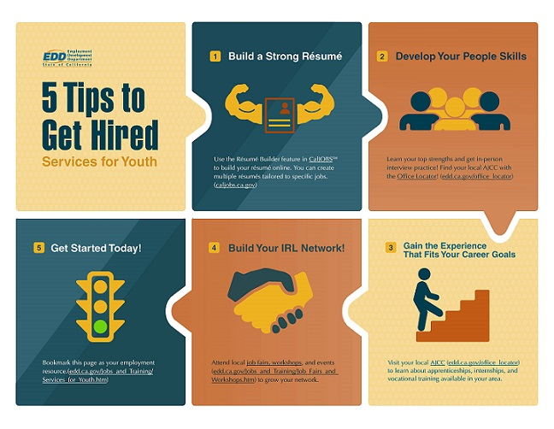
- Build a Strong Résumé.
Use the Résumé Builder feature in CalJOBSSM to build your résumé online. You can create multiple résumés tailored to specific jobs.
- Develop Your People Skills.
Learn your top strengths and get in-person interview practice! Find your local AJCC with the Office Locator.
- Gain the Experience That Fits Your Career Goals.
Visit your local AJCC to learn about apprenticeships, internships, and vocational training available in your area.
- Build Your IRL Network.
Attend local job fairs, workshops, and events to grow your network.
- Get Started Today!
Bookmark this page as your employment resource.

Education and Training Programs
If you are between the ages of 14-24 years old and meet certain eligibility requirements, you may qualify for the following services, available through your local America’s Job Center of CaliforniaSM:

