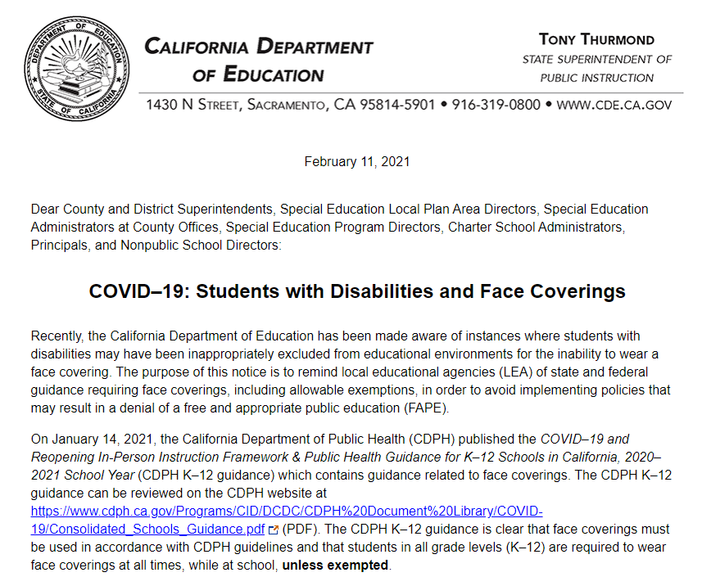On November 16, 2020, the California Department of Public Health released updated Guidance for the Use of Face Coverings (CDPH Face Coverings guidance), which can be reviewed on the CDPH website at https://www.cdph.ca.gov/Programs/CID/DCDC/Pages/COVID-19/guidance-for-face-coverings.aspx. The CDPH guidance clearly outlines individuals exempt from wearing face coverings at all times, regardless of setting. Those exempt individuals include:
- Persons younger than two years old. These very young children must not wear a face covering because of the risk of suffocation.
- Persons with a medical condition, mental health condition, or disability that prevents wearing a face covering. This includes persons with a medical condition for whom wearing a face covering could obstruct breathing or who are unconscious, incapacitated, or otherwise unable to remove a face covering without assistance. Such conditions are rare.
- Persons who are hearing impaired, or communicating with a person who is hearing impaired, where the ability to see the mouth is essential for communication.
- Persons for whom wearing a face covering would create a risk to the person related to their work, as determined by local, state, or federal regulators or workplace safety guidelines.
The CDPH Face Coverings guidance refers to the Centers for Disease Control and Prevention (CDC) face coverings website at https://www.cdc.gov/coronavirus/2019-ncov/prevent-getting-sick/cloth-face-cover-guidance.html#evidence-effectiveness for additional information and resources regarding masks and face coverings. The CDC face coverings website acknowledges that certain groups of people may find it difficult to wear a mask, including some children 2 years (and older) and people of any age with certain disabilities. According to the CDC face coverings website:
Appropriate and consistent use of masks may be challenging for some children and for people of any age with certain disabilities, including cognitive, intellectual, developmental, sensory, and behavioral disorders.
When deciding if children and people with certain disabilities should wear a mask, determine if they can:
- Use a mask correctly
- Avoid frequent touching of the mask and their face
- Limit sucking, drooling, or having excess saliva on the mask
- Remove the mask without assistance
If children and people with certain disabilities are unable to wear a mask properly or cannot tolerate a mask, they should not wear one.
Students with disabilities must not be excluded from educational environments if their disability prevents them from wearing a face covering. LEAs must continue to adhere to least restrictive environment requirements of the Individuals with Disabilities Education Act (IDEA) when educating students with disabilities, including educating students with disabilities are educated with their nondisabled peers to the maximum extent appropriate (34 Code of Federal Regulations §300.114). It is imperative that LEAs continue to monitor the applicability of existing exemptions to individual students with a disability and avoid implementation of policies related to face coverings that may result in a denial of FAPE under the IDEA.
Should there be any questions related to the above information, please contact the Special Education Division via email at SEDInfo@cde.ca.gov.
Sincerely,
Heather Calomese, Director
Special Education Division
Opportunities for All Branch

