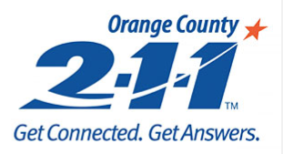

NEED HELP? DIAL 2-1-1 FOR IMMEDIATE SUPPORT
By dialing 2-1-1, you reach a FREE, 24-hour emergency hotline linking you to thousands of local health and human services resources. Staffed 24 hours per day by caring, experienced and trained specialists, 211 Orange County connects you with help for:
- Women, infants and children (WIC) help
- Food and food stamps
- Homeless shelters
- Substance abuse
- Prenatal care
- Help with housing assistance
- Help with utilities
- Emergency housing
- 24-hour crisis, suicide help and suicide counseling
- Mental health services
- Food distribution
- Access to healthcare
- Medical, dental help and vision clinics
- Government assistance programs
- Transportation assistance
- Elder services
- Nutrition assistance
- Help for low-income families
- Other youth and child care issues
- Other physical and mental health services

